[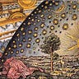](https://cynthiachung.substack.com/)

[**Through A Glass Darkly**](https://cynthiachung.substack.com/)

Upgrade to founding

https://substackcdn.com/image/fetch/w_40,h_40,c_fill,f_auto,q_auto:good,fl_progressive:steep/https%3A%2F%2Fbucketeer-e05bbc84-baa3-437e-9518-adb32be77984.s3.amazonaws.com%2Fpublic%2Fimages%2Fddb50a95-a57a-4867-8796-cb62a884a4ae_393x442.jpeg

[Home](https://cynthiachung.substack.com/)

[Podcast](https://cynthiachung.substack.com/podcast)

[Archive](https://cynthiachung.substack.com/archive)

[About](https://cynthiachung.substack.com/about)

**On Optimism: A Chant of Darkness**

[](https://substack.com/profile/30432817-cynthia-chung)

[Cynthia Chung](https://substack.com/@cynthiachung)

Dec 29, 2022

77

[17](https://cynthiachung.substack.com/p/on-optimism-a-chant-of-darkness-11c/comments)

3

[Share](javascript:void(0))

Cross-post from [Through A Glass Darkly](https://cynthiachung.substack.com/)

An ode to optimism. -

[Cynthia Chung](https://open.substack.com/users/30432817-cynthia-chung?utm_source=mentions)

[[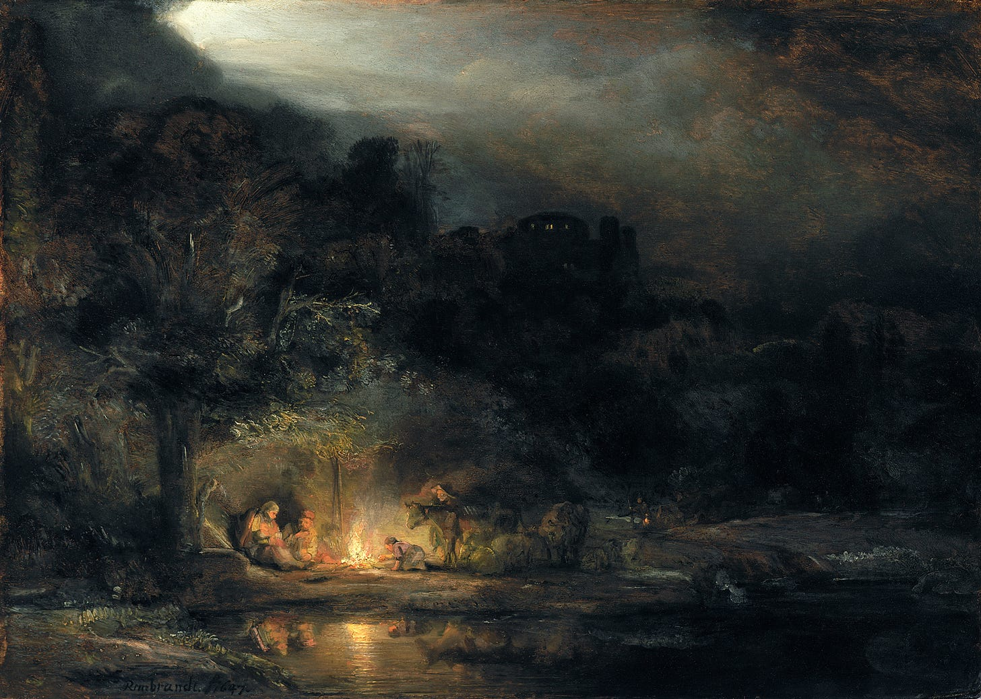](https://substackcdn.com/image/fetch/f_auto,q_auto:good,fl_progressive:steep/https:/substack-post-media.s3.amazonaws.com/public/images/7f0b2b4a-a45c-40c8-b497-38ffd94c7a10_1500x1069.jpeg)](https://substackcdn.com/image/fetch/f_auto,q_auto:good,fl_progressive:steep/https%3A%2F%2Fsubstack-post-media.s3.amazonaws.com%2Fpublic%2Fimages%2F7f0b2b4a-a45c-40c8-b497-38ffd94c7a10_1500x1069.jpeg" \t "_blank)

‘Landscape with the Rest on the Flight into Egypt' (1647) by Rembrandt

“*So my optimism is no mild and unreasoning satisfaction. A poet once said I must be happy because I did not see the bare, cold present, but lived in a beautiful dream. I do live in a beautiful dream; but that dream is the actual, the present – not cold, but warm; not bare, but furnished with a thousand blessings. The very evil which the poet supposed would be a cruel disillusionment is necessary to the fullest knowledge of joy. Only by contact with evil could I have learned to feel by contrast the beauty of truth and love and goodness.”*

– Helen Keller’s paper “[*Optimism*](https://archive.org/details/optimismessay00kelliala)“

The impetus to write a paper focusing on optimism as its primary subject, is oft carried with the dual apprehension of subsequently being swiftly pelted with stones by an angry mob or exiled by critics from “civil society” as an unforgivable fool, with the understanding that those witless enough to follow such a path are always inevitably led to a most terribly tragic ruination, and thus those infected with such mental derangement are best left alone…per chance that it is infectious.

Well I should inform the reader before they go any further, that such a condition is indeed most infectious, and thus you have been warned!

Such opprobrium of optimism reminds me of Plato’s dialogue “[*Gorgias*](https://www.gutenberg.org/files/1672/1672-h/1672-h.htm)*,*” where Socrates (now in his elders years) is mocked by Callicles for being a philosopher in his old age:

*Callicles: And this is true, as you may ascertain, if you will leave philosophy and go on to higher things: for philosophy, Socrates, if pursued in moderation and at the proper age, is an elegant accomplishment,****but too much philosophy is the ruin of human life****. Even if a man has good parts, still, if he carries philosophy into later life, he is necessarily ignorant of all those things which a gentleman and a person of honour ought to know; he is inexperienced in the laws of the State, and in the language which ought to be used in the dealings of man with man, whether private or public, and utterly ignorant of the pleasures and desires of mankind and of human character in general. And people of this sort, when they betake themselves to politics or business, are as ridiculous as I imagine the politicians to be, when they make their appearance in the arena of philosophy.*

***Philosophy, as a part of education, is an excellent thing, and there is no disgrace to a man while he is young in pursuing such a study; but when he is more advanced in years, the thing becomes ridiculous, and I feel towards philosophers as I do towards those who lisp and imitate children****. For I love to see a little child, who is not of an age to speak plainly, lisping at his play; there is an appearance of grace and freedom in his utterance, which is natural to his childish years. But when I hear some small creature carefully articulating its words, I am offended; the sound is disagreeable, and has to my ears the twang of slavery. So when I hear a man lisping, or see him playing like a child, his behaviour appears to me ridiculous and unmanly and worthy of stripes. And I have the same feeling about students of philosophy;****when I see a youth thus engaged,—the study appears to me to be in character, and becoming a man of liberal education, and him who neglects philosophy I regard as an inferior man, who will never aspire to anything great or noble. But if I see him continuing the study in later life, and not leaving off, I should like to beat him, Socrates****; for, as I was saying, such a one, even though he have good natural parts, becomes effeminate. He flies from the busy centre and the market-place, in which, as the poet says, men become distinguished; he creeps into a corner for the rest of his life, and talks in a whisper with three or four admiring youths, but never speaks out like a freeman in a satisfactory manner.*

To Callicles, philosophy is an acceptable, even a necessary part of our development during youth to obtain nobility. However, it becomes something suddenly abhorrent when practised during adult years and is absolutely sickening to behold in one’s elder years, to the extent that Callicles states he feels the desire to beat such a person (insinuating Socrates), for they reek of weakness and effeminacy to which he cannot stand.

In this sense, optimism shares a similar plight with that of philosophy. Optimism too is regarded as something charming and wonderful to behold in a young child and, if the child were imbued by its opposite and were mostly cynical of all things, we would think there was something most dreadfully wrong.

This is a rather curious thing since it is expected that by the time we reach adulthood, we will partake more in cynicism than of optimism, with the gap ever widening as we age. In fact, as we progress through our adult years it is most often the case that we no longer really have a concept of what optimism is, it resembling more a mirage, a dream than something tangible and partaking in reality, or at best we relegate it to “a state of mind” where one can overcome personal barriers but that is typically the extent. The majority conclude by their middle years that optimism does not really have an effect in the governance of the world that we live in – it cannot end wars, alleviate poverty or make society more just. Nobody changes themselves first to fit an optimistic future yet to become, people are pragmatists and will only change if there is something to be gained, “the proof is in the pudding” so to speak.

If this is truly the state of affairs, and the world is governed by selfish pragmatism, why do we encourage our children to dream, to believe in goodness, to oppose injustice and to be defenders of virtue in the world they live in? Why do we tell our children epic stories of heroism and overcoming the odds, invoking wildly vivid imaginations of fantastical upon fantastical? Why do we do such a thing if the world they will step into is truly ugly, cold, unimaginative, unremorseful and ultimately unchanging? Aren’t we preparing their spirits to be shattered and broken? Are we not serving them up to be devoured? Why encourage the cultivation of something during youth, only to dismiss its application in adulthood and condemn its victims to a life of torment!?

It is a terrible thing to invoke a lively imagination, only to stifle it when it is ready to mature its meanderings into more cogent challenges as to why things are the way they are and not otherwise.

In truth, to behold a child makes us all momentary converts of optimism. A child is one of the most striking refutations of a cynical outlook of humankind, for a child is full of love, an insatiable curiosity, adventure, and is a natural rebel to anything authoritarian. Thus, many classical children’s stories may be best understood as not something written *for just children*, but rather was written as an effect of being in the presence of a child’s mind, that is, it is the child that is re-invoking the archaic relic of imagination in those adults who can “listen” and “remember” the secret language of a child’s imagination.

Thus we should ask ourselves, why do we believe in a world of goodness and virtue when we allow ourselves to re-enter the imaginative mind of a child, as an adult? Is this a form of regression? Is such a person running away from reality, no different from a lunatic; completely dysfunctional and thus of no use to society?

As Callicles made the point, what use is philosophy as a “career”? What contribution to the world of grown men can philosophy possibly make? It is also Callicles’ conviction that justice is the rule of the superior over the inferior, the strong over the weak. Though in some ways our society is different from that of Callicles in ancient Athens, in this conception, we are not very unlike each other.

In our world, money and influence are just as much ascribed to what constitutes power and “what makes the world go round” as it did during Callicles time.

“*But when I hear some small creature carefully articulating its words, I am offended; the sound is disagreeable, and has to my ears the twang of slavery.*“

Interestingly, what Callicles considers noble in a child’s development is the very thing that he associates with an abiding slave in later years. The reason for this is because Callicles equates a “real man” to be one that invokes power. A child plays in philosophy as exercises for the mind but is expected to throw away this form of play when they reach adulthood and use such lessons purely in the pursuit of power. In the eyes of Callicles, anyone who does not pursue power is weak and effeminate and partakes more in slavery than in freedom; for it is the most powerful who are the most free and the least powerful who are the most enslaved.

But what if money and influence were not the ultimate culmination of power? What if true power resides somewhere else? Wouldn’t we also have to conclude that wherever this true power resides would also have to be the determining governing force of the world we live in and what ultimately shapes our very own character?

**Out of the Unchartered, Unthinkable Dark We Came**

*Then came Love, bearing in her hand  
The torch that is the light unto my feet,  
And softly spoke Love: “Hast thou  
Entered into the treasures of darkness?  
Has thou entered into the treasures of the night*?

– A Chant of Darkness (an excerpt of the poem by Helen Keller)

[Cynthia Chung:] To answer such a question we will look at one of the unlikeliest of individuals, or so you may think, Helen Keller.

Helen Keller was born June 27, 1880, in Tuscumbia, in a little town of northern Alabama. About nineteen months later, in the dreary month of February, Helen caught an acute congestion of the stomach and brain. Helen describes it in her autobiography ‘*The Story of My Life*‘ as such:

*The doctor thought I could not live. Early one morning, however, the fever left me as suddenly and mysteriously as it had come. There was great rejoicing in the family in that morning, but no one, not even the doctor, knew that I should never see or hear again.*

*I fancy I still have confused recollections of that illness. I especially remember the tenderness with which my mother tried to soothe me in my waking hours of fret and pain, and the agony and bewilderment with which I awoke after a tossing half sleep, and turned my eyes, so dry and hot, to the wall, away from the once loved light, yet came to me dim and yet more dim each day. But, except for these fleeting memories, it all seems very unreal, like a nightmare. Gradually I got used to the silence and darkness that surrounded me and forgot that it had ever been different, until she came – my teacher – who was to set my spirit free. But during my first nineteen months of my life I had caught glimpses of broad, green fields, luminous sky, trees and flowers which the darkness that followed could not wholly blow out. If we have once seen, “the day is ours, and what the day has shown.”*

For about five and a half years Helen grew up in complete darkness and silence without any means to gather information of her surroundings or means of communication, other than basics wants. She lived moment to moment, her world was shaped purely by a whirlwind of raw emotion from euphoric pleasure when she got what she wanted to a fury of rage in the form of wild screams and kicks when she didn’t.

Helen describes one of these moments of rage that nearly led to the death of her younger sister:

*once I discovered my little sister sleeping peacefully in the cradle [Helen’s baby doll’s cradle]. At this presumption on the part of one to whom as yet no tie of love bound me I grew angry. I rushed upon the cradle and over- turned it, and the baby might have been killed had my mother not caught her as she fell. Thus it is that when we walk in the valley of twofold solitude we know little of the tender affections that grow out of endearing words and actions and companionship. But afterward, when I was restored to my human heritage, Mildred and I grew into each other’s hearts, so that we were content to go hand- in-hand wherever caprice led us, although she could not understand my finger language, nor I her childish prattle.*

Helen lived this way, in an almost feral condition until she met her teacher, Anne Sullivan, who was sent from the Perkins Institute for the Blind. Luckily, Helen’s mother had heard of the institute from Charles Dicken’s ‘American Notes’ which describes Laura Bridgman, the first documented deaf-blind person to have ever been educated, and this was accomplished at Perkins.

Helen was an unruly child and rather mischievous. The first day Anne Sullivan arrived to their homestead (she was to live in the same house as Helen’s teacher), Helen managed to lock Anne Sullivan in her room and hid the key. No amount of commotion could sway Helen to reveal the location of the key and her father had to help Anne out of her room through her bedroom window and onto a ladder. Helen only produced the key months later.

As Helen describes it herself, in her “*still, dark world…there was no strong sentiment or tenderness.*” Helen could not love anything in this state, for she had no link to the world of thought, of ideas. The world of Helen was an impatient world of desires and disappointments, how could one be patient if one didn’t even have a concept of a day, let alone a concept of the treasures of the past and the riches of the future?

[[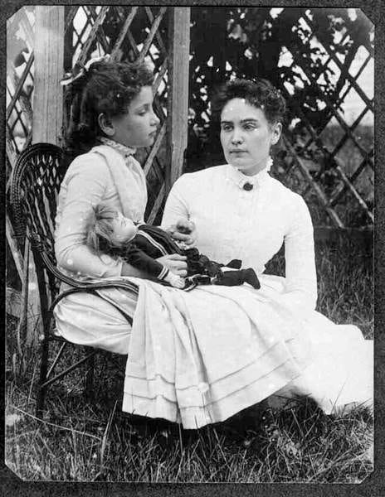](https://substackcdn.com/image/fetch/f_auto,q_auto:good,fl_progressive:steep/https:/bucketeer-e05bbc84-baa3-437e-9518-adb32be77984.s3.amazonaws.com/public/images/13e6636b-b590-44bb-b98c-0bd3e4db80e7_464x600.jpeg)](https://substackcdn.com/image/fetch/f_auto,q_auto:good,fl_progressive:steep/https%3A%2F%2Fbucketeer-e05bbc84-baa3-437e-9518-adb32be77984.s3.amazonaws.com%2Fpublic%2Fimages%2F13e6636b-b590-44bb-b98c-0bd3e4db80e7_464x600.jpeg" \t "_blank)

Helen Keller (to the left) and Anne Sullivan (to the right)

Anne Sullivan was in the process of teaching Helen the sign words for objects around the house. At first amused at the new game, Helen was eager to learn the hand tricks, however, soon grew tired of it suspecting it to be more a mandatory chore than a real game. Helen was especially frustrated with how there could be a word for cup and a different word for the water in the cup. To Helen, it made perfect sense that the water in the cup should also be called cup, and the exercise was left for another day.

The next day, Helen grew into a fury over Anne attempting to return to the exercise on cup vs water, and she threw the doll that was given to her as a gift the day of Anne’s arrival (Helen would find out much later that it had been carefully made by the blind girls at the Perkins Institute), she describes the situation as such:

*I became impatient at her repeated attempts and, seizing the new doll, I dashed it upon the floor. I was keenly delighted when I felt the fragments of the broken doll at my feet. Neither sorrow nor regret followed my passionate outburst. I had not loved the doll. In the still, dark world in which I lived there was no strong sentiment or tenderness. I felt my teacher sweep the fragments to one side of the hearth, and I had a sense of satisfaction that the cause of my discomfort was removed. She brought me my hat, and I knew I was going out into the warm sunshine. This thought, if a wordless sensation may be called a thought, made me hop and skip with pleasure.*

*We walked down the path to the well-house, attracted by the fragrance of the honeysuckle with which it was covered. Some one was drawing water and my teacher placed my hand under the spout. As the cool stream gushed over one hand she spelled into the other the word water, first slowly, then rapidly. I stood still, my whole attention fixed upon the motions of her fingers. Suddenly I felt a misty consciousness as of something forgotten a thrill of returning thought; and somehow the mystery of language was revealed to me. I knew then that “w-a-t-e-r” meant the wonderful cool something that was flowing over my hand. That living word awakened my soul, gave it light, hope, joy, set it free! There were barriers still, it is true, but barriers that could in time be swept away.*

*I left the well-house eager to learn. Everything had a name, and each name gave birth to a new thought. As we returned to the house every object which I touched seemed to quiver with life. That was because I saw everything with the strange, new sight that had come to me. On entering the door I remembered the doll I had broken. I felt my way to the hearth and picked up the pieces. I tried vainly to put them together. Then my eyes filled with tears; for I realized what I had done, and for the first time I felt repentance and sorrow.*

It is most striking to note here, that Helen described her first realisation that **there was such a thing as language as an immediate connection**, an immediate understanding that there was such a thing as thoughts, which required the use of language to not only communicate with others but with ourselves in the form of inner dialogue. Not only this, but Helen credits her new awareness of thought as what directly gave her almost immediate access to the feeling of repentance and sorrow.

Helen recounts how shortly after, she came to understand the concept of love:

*I remember the morning that I first asked the meaning of the word, “love.” This was before I knew many words. I had found a few early violets in the garden and brought them to my teacher. She tried to kiss me: but at that time I did not like to have any one kiss me except my mother. Miss Sullivan put her arm gently round me and spelled into my hand, “I love Helen”  
“What is love?” I asked.  
She drew me closer to her and said, “It is here,” pointing to my heart, whose beats I was conscious of for the first time. Her words puzzled me very much because I did not then understand anything unless I touched it.  
I smelt the violets in her hand and asked, half in words, half in signs, a question which meant, “Is love the sweetness of flowers?”  
“No,” said my teacher.  
Again I thought. The warm sun was shining on us.  
“Is this not love?” I asked, pointing in the direction from which the heat came. “Is this not love?”  
It seemed to me that there could be nothing more beautiful than the sun, whose warmth makes all things grow. But Miss Sullivan shook her head, and I was greatly puzzled and disappointed. I thought it strange that my teacher could not show me love.  
A day or two afterward I was stringing beads of different sizes in symmetrical groups two large beads, three small ones, and so on. I had made many mistakes, and Miss Sullivan had pointed them out again and again with gentle patience. Finally I noticed a very obvious error in the sequence and for an instant I concentrated my attention on the lesson and tried to think how I should have arranged the beads. Miss Sullivan touched my forehead and spelled with decided emphasis, “Think.”  
In a flash I knew that the word was the name of the process that was going on in my head. This was my first conscious perception of an abstract idea.  
For a long time I was still I was not thinking of the beads in my lap, but trying to find a meaning for “love” in the light of this new idea. The sun had been under a cloud all day, and there had been brief showers; but suddenly the sun broke forth in all its southern splendour.  
Again I asked my teacher, “Is this not love?”  
“Love is something like the clouds that were in the sky before the sun came out,” she replied. Then in simpler words than these, which at that time I could not have understood, she explained: “You cannot touch the clouds, you know, but you feel the rain and know how glad the flowers and the thirsty earth are to have it after a hot day. You cannot touch love either; but you feel the sweetness that it pours into everything. Without love you would not be happy or want to play.”  
The beautiful truth burst upon my mind I felt that there were invisible lines stretched between my spirit and the spirits of others.*

This is again incredibly striking, Helen is describing here that her first realisation, her first understanding of love was not through a physical act of love, for ex. a warm hug, a tender caress, kiss on the cheek, pat on the head, etc, but rather, through her ability to conceptualise love as an abstract idea, through her teacher’s emphasis on the process of thought. Only when Helen understood love as something all encompassing and yet something that could not be touched, did she have an understanding of the most profound form of love, like “*invisible lines stretched between my spirit and the spirits of others.*“

*Thus I came up out of Egypt and stood before Sinai, and a power divine touched my spirit and gave it sight, so that I beheld many wonders. And from the sacred mountain I heard a voice which said, “Knowledge is love and light and vision”*

*…Have you ever been at sea in a dense fog, when it seemed as if a tangible white darkness shut you in, and the great ship, tense and anxious, groped her way toward the shore with plummet and sounding-line, and you waited with beating heart for something to happen? I was like that ship before my education began, only I was without compass or sounding-line, and had no way of knowing how near the harbour was. “Light! give me light!’ was the wordless cry of my soul, and the light of love shone on me in that very hour…As my knowledge of things grew I felt more and more the delight of the world I was in.*

[[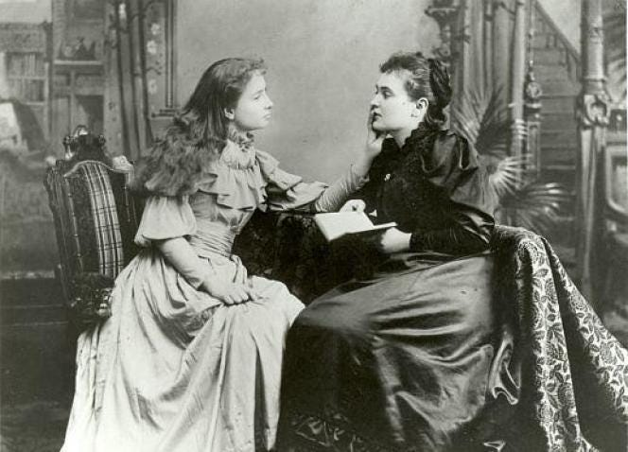](https://substackcdn.com/image/fetch/f_auto,q_auto:good,fl_progressive:steep/https:/bucketeer-e05bbc84-baa3-437e-9518-adb32be77984.s3.amazonaws.com/public/images/3a088c81-790a-4073-8167-ddd66daad359_664x478.jpeg)](https://substackcdn.com/image/fetch/f_auto,q_auto:good,fl_progressive:steep/https%3A%2F%2Fbucketeer-e05bbc84-baa3-437e-9518-adb32be77984.s3.amazonaws.com%2Fpublic%2Fimages%2F3a088c81-790a-4073-8167-ddd66daad359_664x478.jpeg" \t "_blank)

Helen Keller (to the left) and Anne Sullivan (to the right). Anne Sullivan reading a book to Helen who is “listening” by using her hand on Anne’s mouth.

*Thus it was not the sense of touch that brought me knowledge. It was the awakening of my soul that first rendered my senses their value, their cognizance of objects, names, qualities and properties. Thought made me conscious of love, joy, and all the emotions. I was eager to know, then to understand, afterward to reflect on what I knew and understood, and the blind impetus, which had driven me hither and thither at the dictates of my sensations, vanished forever.*

*– ‘The World I Live In’*

I think this a good time to address some of the criticism I have encountered of Helen Keller, namely that she is a “privileged, white person” from a very well-off family, and thus had access to the best resources (despite her living five and half years in silent darkness) and that her “achievements” are thus over-inflated and celebrate more her privilege rather than anything she achieved of her very own merit. This criticism of Keller seems to be making the point that anything achieved with privilege, including education, is not due to personal merit as well, and that those who were born impoverished, as well as deaf-blind, are unjustly relegated to the shadows unable to shine and receive well-deserved recognition for their struggles in the wake of the titanic celebrity of Helen Keller, such as Geraldine Lawhorn, a black deaf-blind woman who lived during the same period as Helen Keller and who only had the opportunity to achieve a degree at the age of 67 in 1983 (Helen Keller was the first deaf-blind person to achieve a degree at the age of 24 in 1916).

I think this is a dangerous line of argument, and rather than address how to resolve the inequality and poverty of sectors of society, it rather condemns those who have access to resources and tools of learning. Education is treated as a privilege, it should not be the case but it is, not everyone has access to an equal education. However, is the solution to this inequality to attack the education? Or, rather, does it not make more sense that the unequal opportunity to access such an education is what needs to be addressed and corrected. A quality education, that is an education on how to cultivate thought, reflection, hypothesize, problem-solve, this is the *true solution* to ending the greatest epidemic of poverty- the poverty of ignorance. We do not rise by dragging others down.

It is absurd to state that Keller’s privilege was a setback to others, rather her success was proof that the mind’s understanding was not ultimately dependent on our sense-perception to determine reality, and that the mind rather came at an understanding of reality through abstract thought. It is not often discussed in this light, but the very existence of Keller as a phenomenon was a challenge to how science and empirical knowledge were taught. Keller was a living disproof of these dominant theories of what constituted ‘mind’ and ‘reality.’

What these critics of Keller fail to understand is that her triumph is not that of just individual triumph, it is a shared triumph for what makes us truly good and truly human, no matter what part of the world you come from, what language you speak and what culture you were immersed in, Keller’s story is a universal story that we can all relate to and learn from. It showcases how we access our most profound self, through the realm of thought, and dare I say it, philosophy.

**What It Is to Be An Optimist**

*The silent worker is imagination which decrees reality out of chaos*.

– Helen Keller

*As my experiences broadened and deepened, the indeterminate, poetic feelings of childhood began to fix themselves in definite thoughts. Nature – the world of touch – was folded and filled with myself. I am inclined to believe those philosophers who declare that we know nothing but our own feelings and ideas. With a little ingenious reasoning one may see in the material world simply a mirror, an image of permanent mental sensations. In either sphere self-knowledge is the condition and the limit of our consciousness. That is why, perhaps, many people know so little about what is beyond their short range of experience. They look within themselves – and find nothing! Therefore they conclude that there is nothing outside themselves, either.*

*– ‘The World I Live In’*

As Helen would write of philosophy in her paper “[*The World I Live In*](https://archive.org/details/worldilivein00kelluoft)“:

*A deaf-blind person ought to find special meaning in Plato’s Ideal World. These things which you see and hear and touch are not the reality of realities, but imperfect manifestations of the Idea, the Principle, the Spiritual; the Idea is the truth, the rest is delusion.*

“*The Idea is the truth, the rest is delusion*,” though Keller had been thrown into a world of silent darkness, she was able to find her way back to her mind and soul, and this path was completely devoid of any experience through sense-certainty. Though Keller had encountered at such a young age a terrifying adversity, she had conquered it, and was now ahead of most. For through her ordeals she discovered where truth lies and recognized the folly of a “practical reality,” which though most treated as concrete fact, was in actuality the delusion, they were “missing the forest for the trees.”

Helen continues in her paper:

*Thus from philosophy I learn that we see only shadows and know only in part, and that all things change; but the mind, the unconquerable mind, compasses all truth, embraces the universe as it is, converts the shadows to realities and makes tumultuous changes seem but moments in an eternal silence, or short lines in the infinite theme of perfection, and the evil but “a halt on the way to good.”*

Here Keller makes the point that our mind, even a mind immersed in silent darkness is unconquerable and embraces the universe as it is, that is, the organizing of understanding within the mind is akin to a universal understanding, an understanding based in natural law. Our minds were shaped by natural law and thus we are its adherents.

“*Man looks within himself and in time finds the measure and the meaning of the universe.*“

Thus, with this understanding, evil is not something that exists exterior to us but rather, exists within us, it represents the struggle between ignorance and wisdom, and this struggle is always a spiritually painful one, for we feel that a part of us must die for the other part to grow. To know evil is to know this struggle and if one is successful in conquering it, one cannot help but become an optimist in consequence: “*The very evil which the poet supposed would be a cruel disillusionment is necessary to the fullest knowledge of joy. Only by contact with evil could I have learned to feel by contrast the beauty of truth and love and goodness.”*

Optimism, that is, not the optimism of the foolish nor the fanciful but the wise, is thus something that does not partake in the present and is in a sense, the understanding of what constitutes the direction of the future based on the recognition of the fundamental laws of the universe that are grounded in the good, the true and the ever-perfecting.

*Philosophy constantly points out the untrustworthiness of the five sense and the important work of reason which corrects the errors of sight and reveals its illusions. If we cannot depend on five sense, how much less may we rely on three! What ground have we for discarding light, sound, and color as an integral part of our world? How are we to know that they have ceased to exist for us? We must take their reality for granted, even as the philosopher assumes the reality of the world without being able to see it physically as a whole.*

*Ancient philosophy offers an argument which seems still valid. There is in the blind as in the seeing an Absolute which gives truth to what we know to be true, order to what is orderly, beauty to the beautiful, touchableness to what is tangible. If this is granted, it follows that this Absolute is not imperfect, incomplete, partial. It must needs go beyond the limited evidence of our sensations, and also give light to what is invisible, music to the musical that silence dulls. Thus mind itself compels us to acknowledge that we are in a world of intellectual order, beauty, and harmony. The essences, or absolutes of these ideas, necessarily dispel their opposites which belong with evil, disorder and discord. Thus deafness and blindness do not exist in the immaterial mind, which is philosophically the real world, but are banished with the perishable material senses. Reality, of which visible things are the symbol, shines before my mind. While I walk about my chamber with unsteady steps, my spirit sweeps skyward on eagle wings and looks out with unquenchable vision upon the world of eternal beauty.*

*-‘The World I Live In’*

There is a reason why the great scientist Gottfried Leibniz stated “*we live in the best of all possible worlds*,” to which Voltaire, mocked in his hyperbole “*Candide*.” Why did [one of the greatest scientists of all time](https://risingtidefoundation.net/2021/02/07/leibniz-vs-newton-a-clash-of-paradigms/) conclude that we live in *the best of all possible worlds*?

Leibniz was remarking on the laws of the universe, [such as the principle of least action](https://risingtidefoundation.net/2021/02/07/leibniz-vs-newton-a-clash-of-paradigms/), to which even during Fermat’s days in studying the behaviour of light through least action, it was recognised as a “moral attribute” to the principles of physics. The universe was not random but was rather ordered, and the order was a harmonious order!

An optimist thus, is no different from a philosopher who is no different from a scientist who is no different from a poet. All of these rely on the ability to see the world beyond sense-perception, and even beyond what it is in the present, **for what it will become in the future.** In other words, their thoughts are located in a future that is yet to become.

Therefore, power does not lie in wealth and influence which is the true valley of the deaf and the blind (those who have yet to awaken to their mind and soul and are thus the truly enslaved), but rather power is to be in union with these higher principles of the universe, based in natural law as understood through the works of Plato.

What has been built can also be torn down, but the Idea never belongs to an individual, in fact, its origin is not even located in an individual nor a collective. Rather, an Idea exists as a Truth independent of us. This is why an Idea pertaining to truth cannot be destroyed, because it ultimately is not contingent upon our fleeting and inconsistent recognition of such things. Truth does not suddenly come into existence because we claim it so, and thus, it is beyond suppression and is beyond destruction. This is also why the mind will always have access to an Idea pertaining to Truth, when given the right tools for imagination and thought, such that the mind will always find its way back again to its hearth; Truth, as known through love of wisdom.

In this context, it is no great cost that one be mocked by the many in adhering to the principles of optimism, for to be an optimist is to have access to dreams, and as Helen states in her paper on ‘[Optimism](https://archive.org/details/optimismessay00kelliala)‘, “*I do live in a beautiful dream; but that dream is the actual, the present – not cold, but warm; not bare, but furnished with a thousand blessings.*“

*Yet remove the dream-world, and the loss is inconceivable. The magic spell which binds poetry together is broken. The splendor of art and the soaring might of imagination are lessened because no phantom of fadeless sunsets and flowers urges onward to a goal. Gone is the mute permission or connivance which emboldens the soul to mock the limits of time and space, forecast and gather in harvests of achievement for ages yet unborn. Blot out dreams, and the blind lose one of their chief comforts; for in the visions of sleep they behold their belief in the seeing mind and their expectation of light beyond the blank, narrow night justified. Nay, our conception of immortality is shaken. Faith, the motive-power of human life, flickers out. Before such vacancy and bareness the shock of wrecked worlds were indeed welcome. In truth, dreams bring us the thought independently of us and in spite of us that the soul may right*

*Her nature, shoot large sail on lengthening cord,*

*And rush exultant on the Infinite.*

*– ‘The World I Live In’*

[[](https://substackcdn.com/image/fetch/f_auto,q_auto:good,fl_progressive:steep/https:/bucketeer-e05bbc84-baa3-437e-9518-adb32be77984.s3.amazonaws.com/public/images/ec3e0b17-bbc4-473c-89c2-fa0435b9b253_504x487.jpeg)](https://substackcdn.com/image/fetch/f_auto,q_auto:good,fl_progressive:steep/https%3A%2F%2Fbucketeer-e05bbc84-baa3-437e-9518-adb32be77984.s3.amazonaws.com%2Fpublic%2Fimages%2Fec3e0b17-bbc4-473c-89c2-fa0435b9b253_504x487.jpeg" \t "_blank)

Helen Keller

**Feature Cover Image**: Rembrandt’s “Landscape with the Rest on the Flight Into Egypt”

Cynthia Chung is the President of the [Rising Tide Foundation](https://risingtidefoundation.net/) and author of the books “[The Shaping of a World Religion](https://cynthiachung.substack.com/p/my-new-book-is-out-the-shaping-of)” & “[The Empire on Which the Black Sun Never Set,](https://cynthiachung.substack.com/p/my-first-book-is-now-outthe-empire)” consider supporting her work [by making a donation](https://risingtidefoundation.net/support-the-work/) and subscribing to her substack page [Through A Glass Darkly](https://cynthiachung.substack.com/).

***Also watch for free our RTF Docu-Series “***[***Escaping Calypso’s Island: A Journey Out of Our Green Delusion***](https://cynthiachung.substack.com/p/escaping-calypsos-island-a-journey)***” and our CP Docu-Series “***[***The Hidden Hand Behind UFOs***](https://cynthiachung.substack.com/p/the-hidden-hand-behind-ufos-episode)***”.***

[Through A Glass Darkly](https://cynthiachung.substack.com/?utm_source=substack&utm_campaign=publication_embed&utm_medium=web)

[On matters of geopolitics, counterintelligence, revisionist history and cultural warfare.](https://cynthiachung.substack.com/?utm_source=substack&utm_campaign=publication_embed&utm_medium=web)

[By Cynthia Chung](https://cynthiachung.substack.com/?utm_source=substack&utm_campaign=publication_embed&utm_medium=web)

Top of Form



Bottom of Form



**Recommend Through A Glass Darkly to your readers**

On matters of geopolitics, counterintelligence, revisionist history and cultural warfare.

Recommend

[](https://substack.com/profile/30432817-cynthia-chung?utm_source=post-reactions-face)

[https://substackcdn.com/image/fetch/w_80,c_limit,f_auto,q_auto:good,fl_progressive:steep/https%3A%2F%2Fbucketeer-e05bbc84-baa3-437e-9518-adb32be77984.s3.amazonaws.com%2Fpublic%2Fimages%2F88087efe-158a-4a7c-bb5e-881f85dbaf99_1050x600.jpeg](https://substack.com/profile/35911889-rising-tide-foundation?utm_source=post-reactions-face)

[](https://substack.com/profile/5695118-matthew-ehret?utm_source=post-reactions-face)

[](https://substack.com/profile/45222829-a-hewitt?utm_source=post-reactions-face)

[](https://substack.com/profile/100212853-pieter-magre?utm_source=post-reactions-face)

77 Likes

·

[3 Restacks](https://substack.com/note/p-93490463/restacks?utm_source=substack&utm_content=facepile-restacks)

77

[17](https://cynthiachung.substack.com/p/on-optimism-a-chant-of-darkness-11c/comments)

3

[Share](javascript:void(0))

**Top**

**Latest**

**Discussions**

[Sex, Drugs and the Vatican: The Origin of America’s Drug Epidemic](https://cynthiachung.substack.com/p/sex-drugs-and-the-vatican-the-origin)

[How Heroin was Flooded into Black Ghettoes to Profit the Gladio Terrorist Network & the Vatican Bank](https://cynthiachung.substack.com/p/sex-drugs-and-the-vatican-the-origin)

Sep 2 •

[Cynthia Chung](https://substack.com/@cynthiachung)

86

[10](https://cynthiachung.substack.com/p/sex-drugs-and-the-vatican-the-origin/comments)



[The Birth of the Modern Templars, the Origins of the Ancient Scottish Rite and the Roman Sun King Napoleon](https://cynthiachung.substack.com/p/the-birth-of-the-modern-templars)

[The French Connection: The Knights of Malta, the Scottish Rite & the Rise of the Mafia Brotherhoods Part IV](https://cynthiachung.substack.com/p/the-birth-of-the-modern-templars)

Jun 22 •

[Cynthia Chung](https://substack.com/@cynthiachung)

72

[4](https://cynthiachung.substack.com/p/the-birth-of-the-modern-templars/comments)

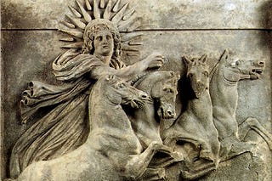

[The French Connection: The Knights of Malta, the Scottish Rite & the Rise of the Mafia Brotherhoods](https://cynthiachung.substack.com/p/the-french-connection-the-knights)

[This story will discuss the Knights of Malta link to the birth of the Italian and French Mafia Brotherhoods, as well as the Mafia Brotherhoods link to…](https://cynthiachung.substack.com/p/the-french-connection-the-knights)

Jun 5 •

[Cynthia Chung](https://substack.com/@cynthiachung)

61

[11](https://cynthiachung.substack.com/p/the-french-connection-the-knights/comments)



See all

© 2024 Cynthia Chung

[Privacy](https://substack.com/privacy) ∙ [Terms](https://substack.com/tos) ∙ [Collection notice](https://substack.com/ccpa#personal-data-collected)

[Start Writing](https://your.substack.com/publish)[Get the app](https://substack.com/app/app-store-redirect?utm_campaign=app-marketing&utm_content=web-footer-button)

[Substack](https://substack.com/) is the home for great culture